**Software Project Management Lab 3**

Group Members:

Arda Celik - 100596185

Marwa Safa - 100585192

Thomas Jansz - 100642111

**Course Project: Photo marketplace**

**1.Estimate Effort**

**1.1Function point:**

|  |  |  |
| --- | --- | --- |
| Requirements | Function type | Complexity |
| The clients could publish their photography and still keep the ownership of the picture. | External output | 4 |
| Allow merchants to create licences and for users to access them | External Input | 4 |
| Apply watermark on copyrighted materials | Internal files | 2 |
| Remove watermark on purchased materials | External Query | 1 |
| Pay based on how popular the contribution are | External output | 4 |
| Total |  | 15 FPs |

**1.2: COCOMO model:** to estimate effort for this project we define this project as an organic project because the requirements are small and straightforward and due to the size of the project. The estimation using COCOMO with organic project will result of formula as

following:

Formula: E = a (KLOC)^b [ E is the effort calculated in person months]

D = c (E)^d [D is the duration calculated in months]

A,b,c, and d are constants and for E we will use the previous similar problem to find the lines of codes. This project is mainly focused on uploading photos and putting it on the website or apps and after our research the estimated lines of code is 700 for web and 500 for the application part. LOC = 700+500 = 1200 lines of codes

E = 2.4*(1.2)^1.05= 2.90 ~ 3 person months

D = 2.5*(3)^0.38 = 3.7 months

Therefore the project is estimated to take 3.7 months with an effort of 32 person months.

**2. Activity Diagram**

Secondly, you’re require to draw an activity diagram for your project. To explain briefly, activities are steps you’re taking in the overall development of your project, from administrative steps such as acquiring software and hardware and recruitment, to developmental steps such as installing the hardware, writing user manuals, coding and testing. Each one of these activities has a total time you can estimate in terms of weeks. Your activities start from Week 0. Below is an example of an activity network

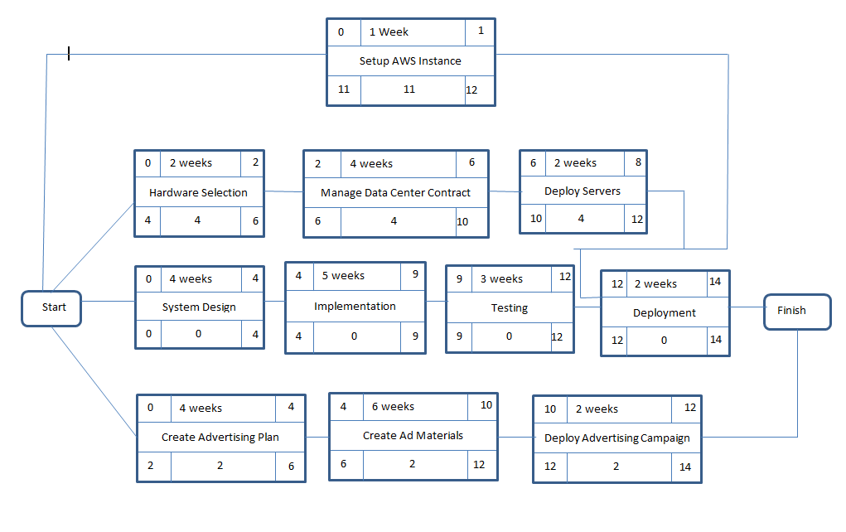

**Finally you are required to document the risks associated with the project. You only need to write descriptions of the kind of risks you can face when developing or deploying your project, and state the kind of countermeasures you’ll put in case. For example, your employees may lack productivity, and in that case, you’ll run strict recruitment process and put together a rigorous training program before beginning the project.**

**3. Risks**

|  |  |  |
| --- | --- | --- |
| Risk | Description | Countermeasure |
| Late changes to requirements | New requirements might come during development or the customer might want to modify the existing requirements | The threshold of change need to be improved where changes in requirements are welcomed. The processes used to manage change should be strict and reviewed on a regular basis. |
| Staff shortfall | The staff might not productive, they might lack skills and experience to complete the project, they may be hard to work with | * Having a criteria in hiring process to make sure the staff is high quality, * Having a solid training for the new employees * Emphasizing team building throughout the process. |
| Unrealistic estimates | The implementation of some parts of the project might take longer than initially estimated which may result with an increase in cost or late delivery | * Multiple estimation techniques should be used * Past projects can be analyzed |